What is Exception Handling?

Exception Handling is a mechanism to handle runtime errors such as ClassNotFoundException, IOException, SQLException, RemoteException, etc.

In Java, an exception is an event that disrupts the normal flow of the program. It is an object which is thrown at runtime.

### **Advantage of Exception Handling**

The core advantage of exception handling is **to maintain the normal flow of the application**. An exception normally disrupts the normal flow of the application; that is why we need to handle exceptions. Let's consider a scenario:

statement 1;

statement 2;

statement 3;

statement 4;

statement 5;//exception occurs

statement 6;

statement 7;

statement 8;

statement 9;

statement 10;

Suppose there are 10 statements in a Java program and an exception occurs at statement 5; the rest of the code will not be executed, i.e., statements 6 to 10 will not be executed. However, when we perform exception handling, the rest of the statements will be executed. That is why we use exception handling in [Java](https://www.javatpoint.com/java-tutorial).

//unchecked exception

public class Main{

public static void main(String[] args){

int i=8,j=0,k=0;

try{

k=i/j;

}

catch(Exception e){

System.out.println("can not divide by zero ");

}

System.out.println(k);

}

}

## Problem without exception handling

**TryCatchExample1.java**

1. **public** **class** TryCatchExample1 {
3. **public** **static** **void** main(String[] args) {
5. **int** data=50/0; //may throw exception
7. System.out.println("rest of the code");
8. }
9. }

Exception in thread "main" java.lang.ArithmeticException: / by zero

As displayed in the above example, the **rest of the code** is not executed (in such case, the **rest of the code** statement is not printed).

There might be 100 lines of code after the exception. If the exception is not handled, all the code below the exception won't be executed.

we also kept the code in a try block that will not throw an exception. if an exception occurs in the try block, the rest of the block code will not execute.

Let's see an example to resolve the exception in a catch block.

**TryCatchExample6.java**

1. **public** **class** TryCatchExample6 {
3. **public** **static** **void** main(String[] args) {
4. **int** i=50;
5. **int** j=0;
6. **int** data;
7. **try**
8. {
9. data=i/j; //may throw exception
10. }
11. // handling the exception
12. **catch**(Exception e)
13. {
14. // resolving the exception in catch block
15. System.out.println(i/(j+2));
16. }
17. }
18. }

# **Java Catch Multiple Exceptions**

## Java Multi-catch block

A try block can be followed by one or more catch blocks. Each catch block must contain a different exception handler.

## Points to remember

* At a time only one exception occurs and at a time only one catch block is executed.
* All catch blocks must be ordered from most specific to most general, i.e. catch for ArithmeticException must come before catch for Exception.

### **Flowchart of Multi-catch Block**

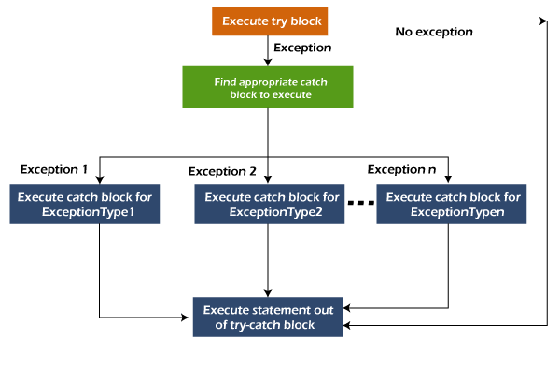

### **Example 1**

Let's see a simple example of java multi-catch block.

**MultipleCatchBlock1.java**

1. **public** **class** MultipleCatchBlock1 {
3. **public** **static** **void** main(String[] args) {
5. **try**{
6. **int** a[]=**new** **int**[5];
7. a[5]=30/0;
8. }
9. **catch**(ArithmeticException e)
10. {
11. System.out.println("Arithmetic Exception occurs");
12. }
13. **catch**(ArrayIndexOutOfBoundsException e)
14. {
15. System.out.println("ArrayIndexOutOfBounds Exception occurs");
16. }
17. **catch**(Exception e)
18. {
19. System.out.println("Parent Exception occurs");
20. }
21. System.out.println("rest of the code");
22. }
23. }

**Output:**

Arithmetic Exception occurs

rest of the code

### **Example 5**

Let's see an example, to handle the exception without maintaining the order of exceptions (i.e. from most specific to most general).

**MultipleCatchBlock5.java**

1. **class** MultipleCatchBlock5{
2. **public** **static** **void** main(String args[]){
3. **try**{
4. **int** a[]=**new** **int**[5];
5. a[5]=30/0;
6. }
7. **catch**(Exception e){System.out.println("common task completed");}
8. **catch**(ArithmeticException e){System.out.println("task1 is completed");}
9. **catch**(ArrayIndexOutOfBoundsException e){System.out.println("task 2 completed");}
10. System.out.println("rest of the code...");
11. }
12. }

**Output:**

Compile-time error

# **Java finally block**

**Java finally block** is a block used to execute important code such as closing the connection, etc.

Java finally block is always executed whether an exception is handled or not. Therefore, it contains all the necessary statements that need to be printed regardless of the exception occurs or not.

The finally block follows the try-catch block.

### **Flowchart of finally block**

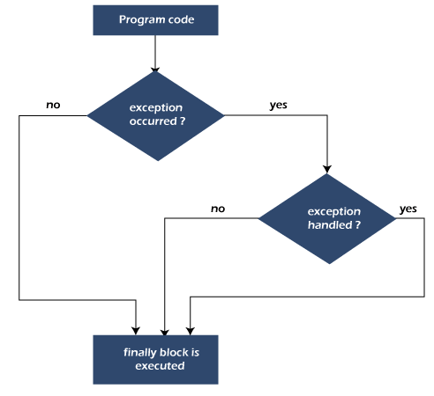

#### **Note: If you don't handle the exception, before terminating the program, JVM executes finally block (if any).**

* The important statements to be printed can be placed in the finally block.

## Usage of Java finally

Let's see the different cases where Java finally block can be used.

### **Case 1: When an exception does not occur**

Let's see the below example where the Java program does not throw any exception, and the finally block is executed after the try block.

**TestFinallyBlock.java**

1. **class** TestFinallyBlock {
2. **public** **static** **void** main(String args[]){
3. **try**{
4. //below code do not throw any exception
5. **int** data=25/5;
6. System.out.println(data);
7. }
8. //catch won't be executed
9. **catch**(NullPointerException e){
10. System.out.println(e);
11. }
12. //executed regardless of exception occurred or not
13. **finally** {
14. System.out.println("finally block is always executed");
15. }
17. System.out.println("rest of phe code...");
18. }
19. }

### **Case 2: When an exception occurr but not handled by the catch block**

Let's see the the fillowing example. Here, the code throws an exception however the catch block cannot handle it. Despite this, the finally block is executed after the try block and then the program terminates abnormally.

**TestFinallyBlock1.java**

1. **public** **class** TestFinallyBlock1{
2. **public** **static** **void** main(String args[]){
4. **try** {
6. System.out.println("Inside the try block");
8. //below code throws divide by zero exception
9. **int** data=25/0;
10. System.out.println(data);
11. }
12. //cannot handle Arithmetic type exception
13. //can only accept Null Pointer type exception
14. **catch**(NullPointerException e){
15. System.out.println(e);
16. }
18. //executes regardless of exception occured or not
19. **finally** {
20. System.out.println("finally block is always executed");
21. }
23. System.out.println("rest of the code...");
24. }
25. }

**Output:**

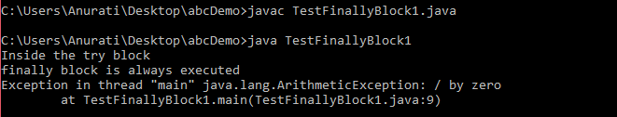

### **Case 3: When an exception occurs and is handled by the catch block**